Vessel Tracking System (VTS) Project
User Interface Specification
Filing Reference : | ISS/VTS/TS.6/1
Document Title: | User Interface Specification
Version : | 1.1
Prepared by : | Plathottam Linu Thankam ,  Naung Naung Latt
Date Created : | 8 Mar 2010
Approved by :
 | Teng Boon Wee |  | Date
 | Project Manager
Authorised by :
 | Chong Imm Lam |  | Date
 | User Manager
© 1994 ISS.  The information contained in this document is the property of ISS. The contents must not be reproduced , wholly or in part, for purposes other than for which it has been supplied, without the prior permission of ISS, or, if it has been furnished under contract to another party, as expressly authorised under that contract. ISS shall not be liable for any errors or omissions. |  | ISS

Document Reference: ISS/VTS/TS.6/1
Version | Date | Author | Authorised by | Date
1.0 | 8-Mar-10 | Linu Thankam, Naung Naung Latt | Chong Imm Lam
Vessel Tracking Project System (VTS)
Vessel Tracking Project.
User Interface Specification
Distribution:
Name | Department | Organisation
Teng Boon Wee | - | ISS
Li Pengfei | - | ISS
Cai Xiang | - | ISS
Erik Araojo | - | ISS
Naung Naung Latt | - | ISS
Oh Chew Key | - | ISS
Plathottam Linu Thankam | - | ISS
Kyaw Thu Lin | - | ISS
Chong Imm Lam | SEG | ST Electronics
Contents
Contents 3
1. Business Analysis 4
1.1. Executive Summary 4
1.2. Objectives: 4
1.3. Competitor Analysis: 4
1.4. Common Features: 5
2. Display Client 6
2.1. Main Page 6
2.2. 7
2.3. Track Display Page 8
2.4. Maps 9
2.5. User Account 12
2.6. Track Manipulator 14
3. Admin Console 19
3.1. Log In Screen 19
3.2. Admin Main Screen 20
3.3. 21
3.4. Change Password Screen 22
3.5. User List Screen 23
3.6. Manage User Screen 24
3.7. Group List Screen 25
3.8. Manage Group Screen 26
3.9. Select Member(s) Screen 28
3.10. Track List Screen 29
3.11. Manage Track 30
3.12. Select Group(s) Screen 32
3.13. Layer List Screen 33
3.14. Manage Layer Screen 34
3.15. Attribute Screen 36

Business Analysis

Executive Summary
The VTS is a vessel tracking system intended to track a number of various vessel. It will be implemented as a distributed system so that multiple clients can be interconnected and exchange information over a network.

Before the team starts on developing the product, we have done client survey with people from different background and collected their personas. This kind of information provides us to be able to describe user characteristics that lead to different collections of needs and behaviors.

Objectives:

Design the following GUI's

- The Admin Portal, which shall provide administration of the whole system.

- The Tracking Client, which shall read positional information from GPS device, and send it to the Information Centre periodically.

- The Display Client, which shall enable remote users to view track information received from the Information Centre.

Competitor Analysis:

The competitor analysis is a vital part of planning the business and identifying GUI. To achieve the business goals and success through our product we need to develop the software based on the knowledge of what the company’s competitors are doing, their strategies and planning. Based on the competitor analysis we can understand how to influence the competitor behavior and make the product more advantage.

We have selected two competitors.

http://www.marinetraffic.com/

http://earth.google.com

Common Features:

- Map display is similar for both products.
- Zoom in and out options.
- Display options.
- Tool tips for providing additional information.

Display Client

Main Page

- Main Page will be displayed while launching the application.
- All Tabs are disabled by default till user gets login
- Some default maps can be put in Map display area panel.
- All the pages will be active only after Login.
Assumption:
If a Tab is selected the sub menu for the tabs will be displayed in the next panel and the selected Main components should be changed the button colour. This will lead the software visibility to the users to back track the location they start from and where they are.

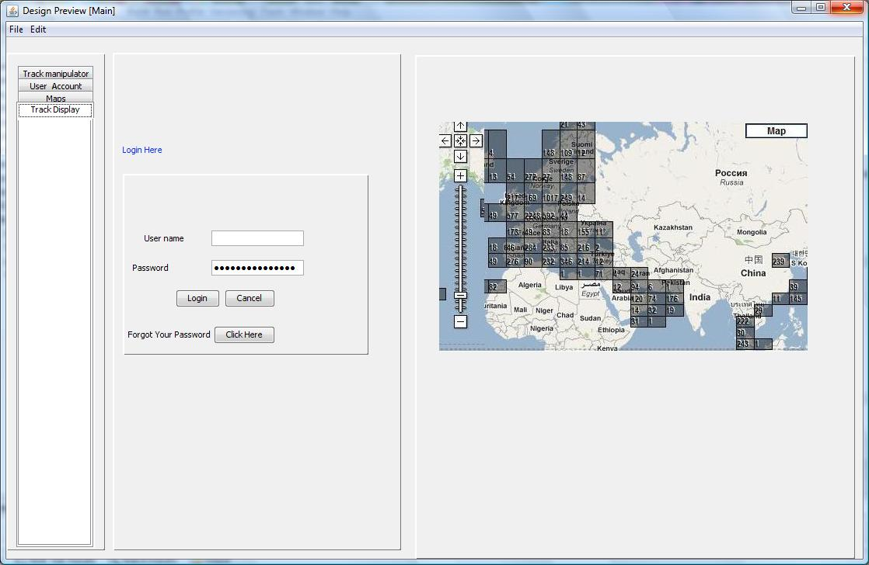

Name | Type | Description
Username | Textbox | For entering of the User ID
Password | Password | For entering of the password
Forgot password | Button | When the user clicks this button, the system will reset the user’s password. The system checks the User ID entered in the Username textbox and validates it to ensure that it is an existing User ID before resetting the password. The new password will be sent mail to the user’s mail account. If the user did not enter a correct User Id or has left the Username textbox empty an error message will pop up.
Login | Button | When the user clicks the Login button, the system will authenticate the User ID and the password. If the User Id is not valid or the password is incorrect, it will prompt error Message.  If authentication and authorization is successful, it will enable the Button in left panel and the track display will start to display the real time map.
Cancel | Button | Upon pressing the Cancel button, the application will exit.

Track Display Page
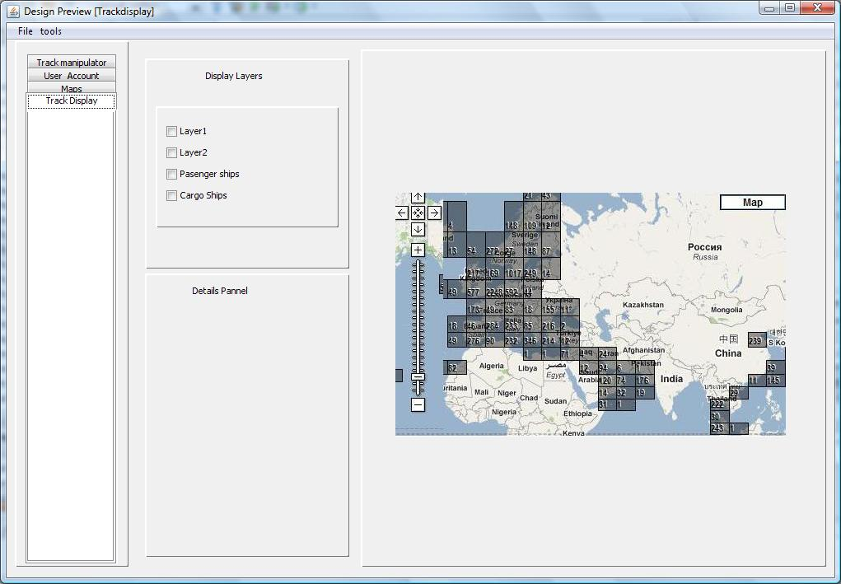

- Clicking on a track will show a tool tip with the track’s details.
- The track details will be displayed in the left panel.
- The visibility of the layers can be toggled by checking and unchecking the checkbox provided in the Display Layers panel.

Name | Type | Description
Display Layers Panel | panel | Contains the Display Layers check boxes. The map will display the track layers according to the checkboxes that are checked.
Details Panel | panel | Details panel will display the details of the track selected.

Maps
Select Layer
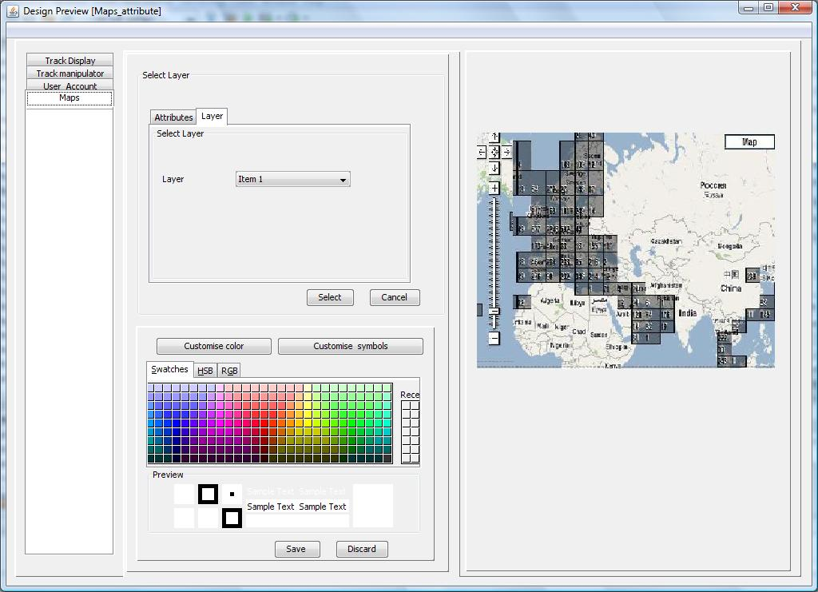

Select Attribute

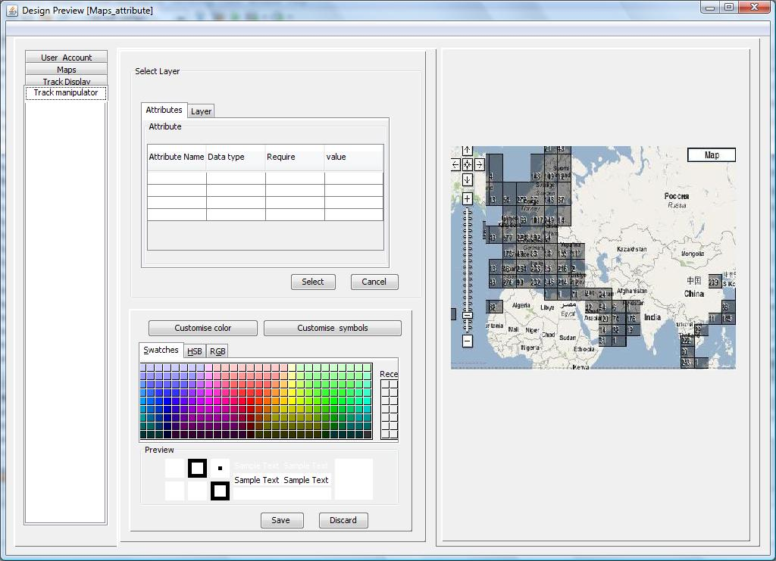

- Select Layer panel will have a tabbed panel. Whenever user selects a Track Layer the attribute page will become active and the user can change the colour or symbol attributes of the layer.
- Change the colour or symbols and click save button.
- Customise map colour / customise Symbols will be allow to select colour/symbols. The selected colour/symbols will be applied to the map when the Save button is pressed.

Name | Type | Description
Customise map colour | button | This will enable the colour palate for selecting the colour for the map.
Customise symbols | button | This will load the symbols.
Save | Button | After change the Layers colour or symbol press the Save button to save the customised colour and symbol.
Discard | Button | Cancel the changed colour/symbol.
Attributes | Tabbed pane tab | This tab contents will be visible only if user selects the Layer.
Layer | Tabbed pane tab | Using this tab user will be able to select the layer. Once the layer is selected, the attributes list will be active.
Select | Button | Select the Layer with its attributes.
cancel | Button | Cancel the selected layer and its attributes.

User Account

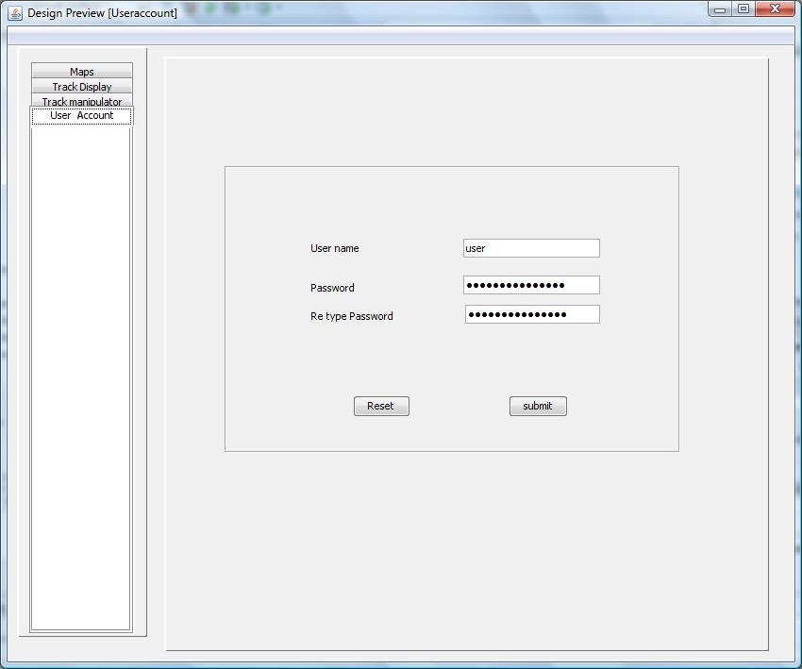
- Users will be allowed to change their own passwords
- The user name will be automatically populated in the User name textbox.
- The password will be changed only if the user keys in the same password for the Password textbox and the Retype Password textbox.

Name | Type | Description
User name | Textbox | Username will be populated automatically (This field should be disabled. User not supposed to enter any data)
Password | Password | For entering of the password
Re-type password | Password | For entering of the password
Submit | Button | To submit the change password form. If the password and retype password is same. And the other password validation also satisfied, it will reset the password. If validation is wrong this will prompt the error message.
Reset | Button | To reset the entered data in the form.

Track Manipulator

Manage My Tracks

Add Track -Select Track
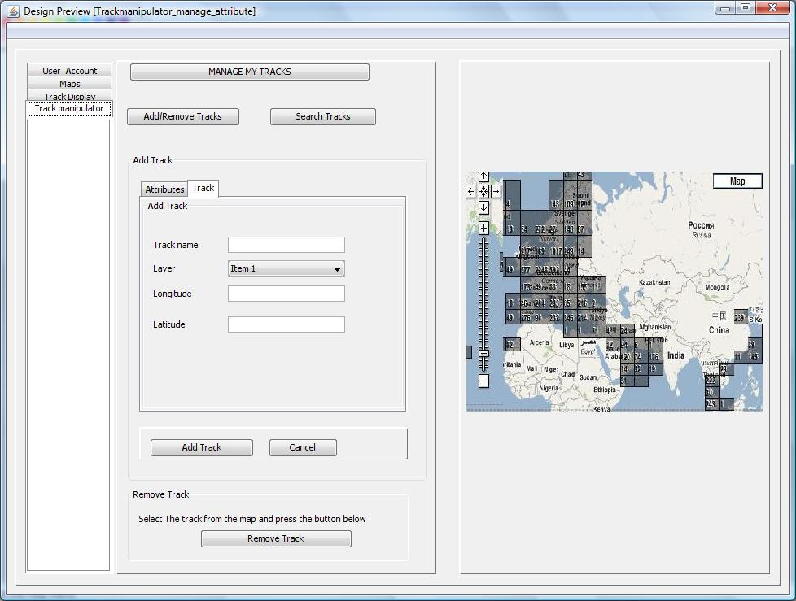

Add Track -Select attributes

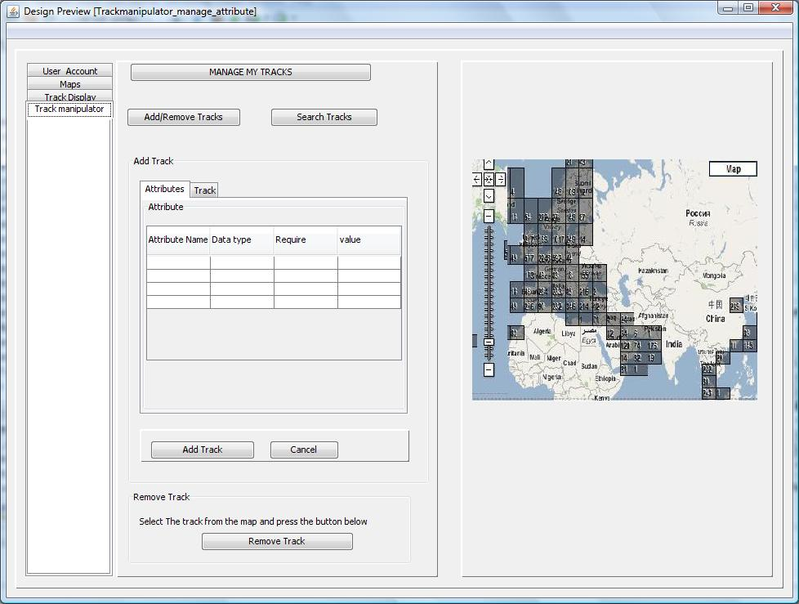

- Map will be displayed by default.
- If the Add/ Remove track button is pressed, the Add Track panel and the Remove Track panel will appear.
- The Add Track panel will have a form to allow the user to enter the attributes of the track. After the attributes have been added the user can press the “Add Track” button to add the track.
- Remove Track panel contains a button to remove tracks. Click on a track on the map and click on “Remove Track” button to delete that track.

Name | Type | Description
Track name | Textbox | To enter the static Track name
Layer | Combo box | To select all Layers available.
Longitude | Text box | To enter Longitude
Latitude | Text box | To enter Latitude
Attributes | Tabbed pane tab | This tab contents will be visible only if user selects the Layer from track tab.
Tracks | Tabbed pane tab | Using this tab user will be able to enter the track details and select the layer. Once the layer is selected, the attributes list will be active.
Delete Track | Button | Select the track from map and press Delete Track button.
Add Track | Button | After enter the data into the form press this button to add track in to the map. If the validation is correct the track will be added. Otherwise will pop up the error message.
Cancel | Button | Cancel the add track operation. It will reset the data in the form and cancel the operation.
Add/Remove Track | Button | This button will enables the panels for doing add/remove operations.
Search Track | Button | This button will enable the panels for Search operations.
SEARCH

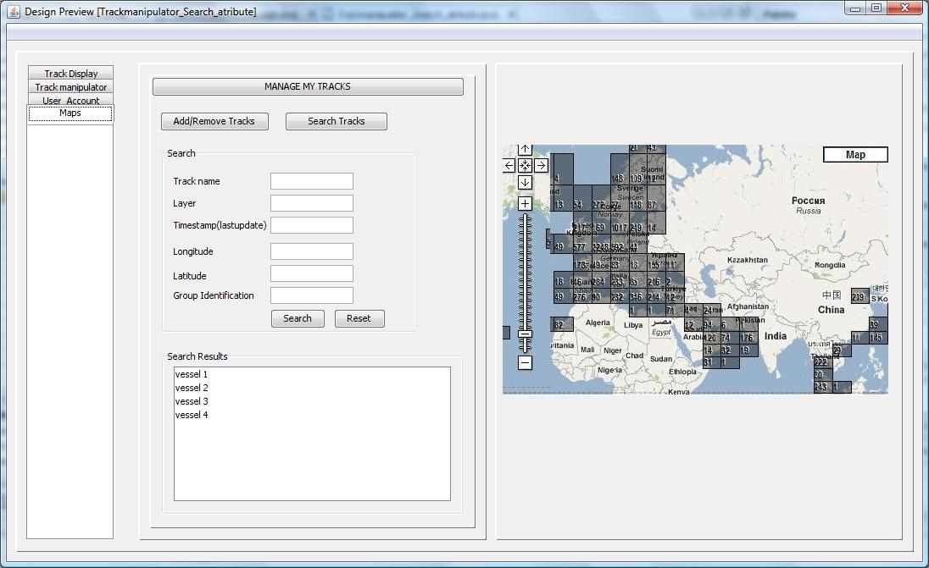

- If the Search Tracks button is pressed, the Search panel and Search Results panel will appear.
- The Search panel will allow user to enter the search criteria.
- The user can click on the Search button in the Search panel to start the search, or click on the Reset button to clear all the fields of the search criteria.
- The Search Results panel will be displayed the result.
- Clicking on the results in the Search Results panel will display the selected track in the map.

Name | Type | Description
Track name | Text box | To enter Track name
Layer | Text box | To enter Layer
Longitude | Text box | To enter Longitude
Latitude | Text box | To enter Latitude
Timestamp ( last update) | Text box | To enter timestamp of last update
Layer attribute values | Text box | To enter Layer attribute value
Group identification | Text box | To enter Group Identification
Search | Button | This button will do a search with the above inputs and list the results in list. If a match could not be found, an error message will pop up.
List | List | This list will have the search results. When ever selects the result it will navigate to the place in the map.
Clear | Button | Reset the search criteria.
Add/Remove Track | Button | This button will enables the panels for doing add/remove operations.
Search Track | Button | This button will enable the panels for Search operations.

Admin Console

Log In Screen

Admin has to log in to access Admin Console.

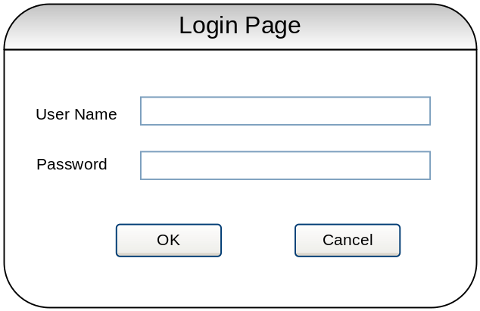

Name | Type | Description
User ID | Textbox | To accept the User ID
Password | Password | To accept the password
OK | Button | Once user clicks OK, system should authenticate a valid user with the administrator credential. If the user id not a valid or do not have admin credential, it should prompt error Message.  If authentication and authorization is successful, it will open Admin Main Console Screen.
Cancel | Button | On the event of pressing Cancel button, system should close the log on screen and close the application.

Admin Main Screen

Admin main screen will appear if the user successfully logs on at the admin logon screen.

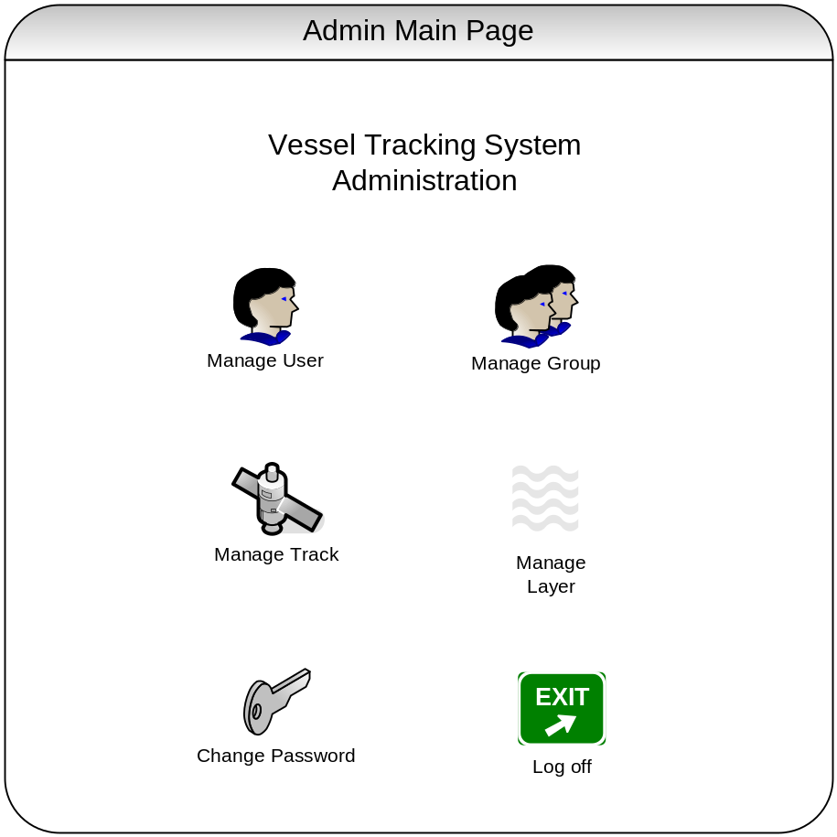

Name | Type | Description
Manage User | Clickable Icon | Once the user clicks on this, it should open up User List Screen.
Manage Group | Clickable Icon | Once the user clicks on this, it should open up Group List Screen.
Manage Track | Clickable Icon | Once the user clicks on this, it should open up Track List Screen.
Manage Layer | Clickable Icon | Once the user clicks on this, it should open up Layer List Screen.
Log off | Clickable Icon | Once the user clicks on this, it should open up Change Password Screen.
Log off | Clickable Icon | Once the user clicks on this, ask for the confirmation and it should end the current user session and go back to log on session.

Change Password Screen

Change password screen will appear when the user clicks Change Password on the Admin Main screen.

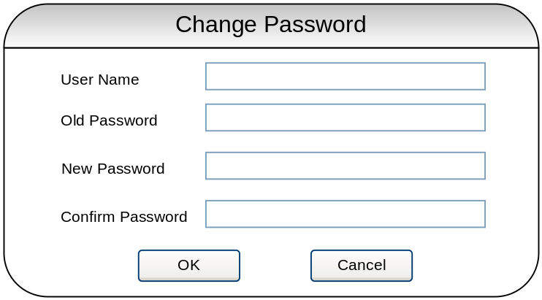

Name | Type | Description
User Name | Read only Text | Display current login user name.
Old Password | Password | To accept the old password
New Password | Password | To accept the new password
Confirm Password | Password | To confirm the new password
OK | Button | Once user clicks OK, system should check New password and Confirm Password are the same and prompt error message if not the same. And system should validate User ID and Old Password and change the password if validation is successful. Otherwise show error message. Password should be case sensitive.
Cancel | Button | On the event of pressing Cancel button, system should close the Change Password Dialog.

User List Screen

The User List screen will appear when the user clicks on Manage User on the Admin Main Screen.

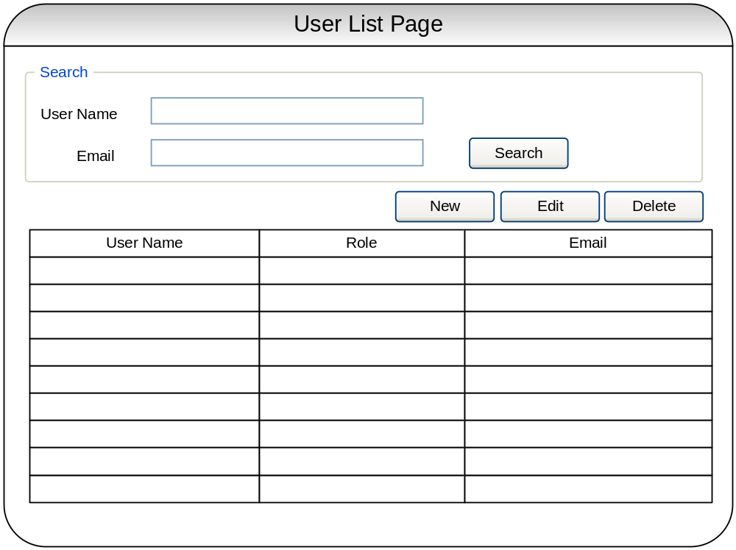

Name | Type | Description
User Name | Textbox | To accept user name as search filter criteria.
Email | Textbox | To accept user’s email as search filter criteria.
Search | Button | Once the user clicks on Search button, it should populate user info into the grid base on the filter criteria.
User Info Grid | Grid | Display list of user info.
New | Button | Once the user clicks on New button, it should open Manage user screen to create new user.
Edit | Button | Once the user clicks on Edit button, it should open Manage user screen to edit selected user info in the grid.
Delete | Button | Once the user clicks on Delete button, it should ask for the confirmation and delete from the database once the user confirm for the deletion.

Manage User Screen

The Manage user screen will appear when the user clicks on the New or the Edit button on the User List screen. The user’s information should be populated in the form fields if user selects the Edit button on the User List screen.

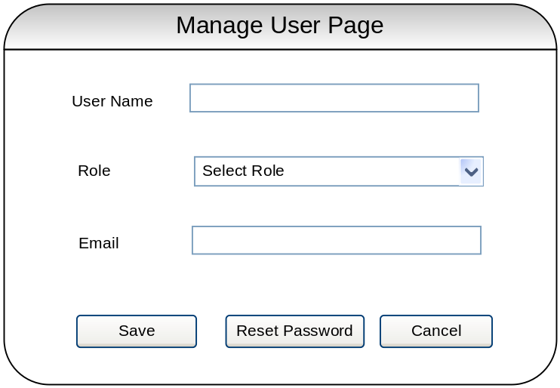

Name | Type | Description
User Name | Textbox | To accept user name. Dim if it is in edit mode.
Role | Dropdown | To accept the role of user (e.g. admin, user).
Email | Textbox | To accept user’s email address.
Save | Button | Once the user clicks on save button, it should perform require validation and save into the database. Password will be auto generated by the system and email to the user. After saving into the database, it should go back to the User List screen and user info grid should be reflected with the changes.
Reset Password | Button | Reset Password should be appeared only on edit user mode.  Once the user clicks on Reset Password, it should re-generate the password and send the password to the user by email.
Cancel | Button | Once the user clicks on Cancel button, it should show changes lost warning message and ask for the confirmation. Close the Manage User screen and go back to User List Screen if user confirm to cancel.

Group List Screen

The Group List screen will appear when the user clicks Manage Group on the Admin Main Screen.

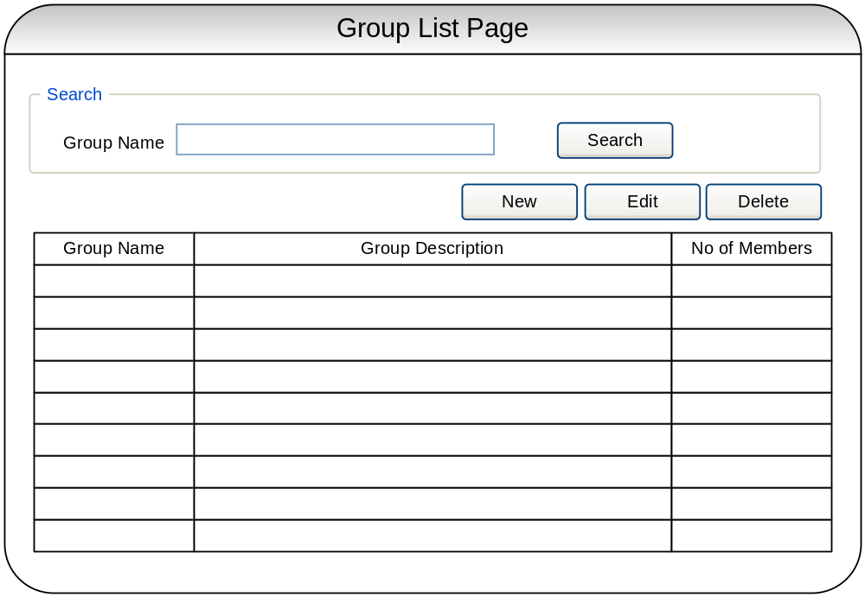

Name | Type | Description
Group Name | Textbox | To accept Group Name as search filter criteria.
Search | Button | Once the user clicks on Search button, it should populate group info into the grid base on the filter criteria.
Group Info Grid | Grid | Display list of group info.
New | Button | Once the user clicks on New button, it should open Manage group screen to create new group.
Edit | Button | Once the user clicks on Edit button, it should open Manage group screen to edit selected group info in the grid.
Delete | Button | Once the user clicks on Delete button, it should ask for the confirmation and delete from the database once the user confirm for the deletion.

Manage Group Screen
The Manage Group screen will appear when the user clicks on the New or the Edit button on the Group List screen. The group information will be populated in the form fields if user selects the Edit button on the Group List screen.

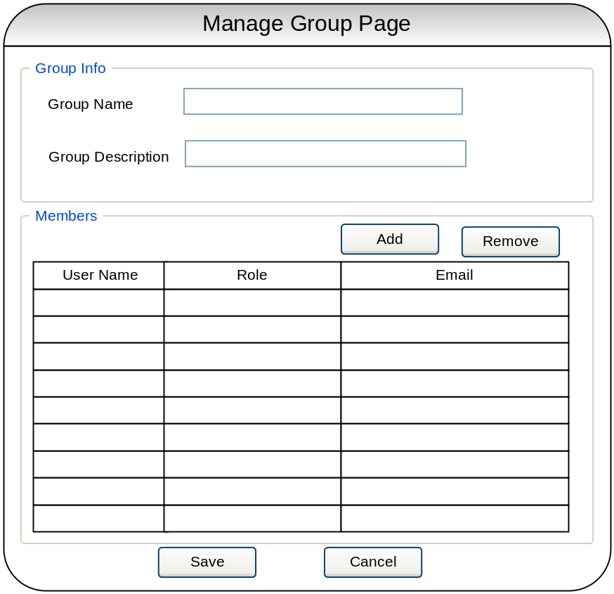

Name | Type | Description
Group Info | Group Box | For the grouping of the group info controls.
Group Name | Textbox | To accept the group name.
Group Description | Textbox | To accept the description of the group.
Members | Group Box | For the grouping of adding and removing members into group.
Member Info Grid | Grid | Display list of members in the group.
Add | Button | Once the user clicks on this button, it should open up the Select Member screen which enables the user to select the member(s) to add in the member list of the group.
Remove | Button | Once the user clicks on this button, selected member(s) will be deleted from the member list of the group.
Save | Button | Once the user clicks on save button, it should perform require validation and save into the database. After saving into the database, it should go back to the Group List screen and group info grid should be reflected with the changes.
Cancel | Button | Once the user clicks on Cancel button, it should show changes lost warning message and ask for the confirmation. Close the Manage Group screen and go back to Group List Screen if user confirms to cancel.

Select Member(s) Screen
The Select Member(s) screen will appear when the user clicks on the Add button on the Manage Group screen.

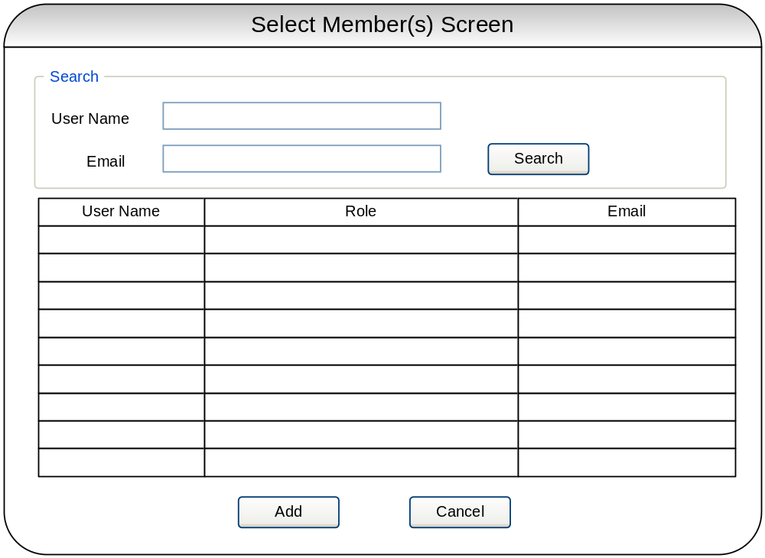

Name | Type | Description
User Name | Textbox | To accept user name as search filter criteria.
Email | Textbox | To accept user email as search filter criteria.
Search | Button | Once the user clicks on Search button, it should populate user info into the grid base on the filter criteria.
User Info Grid | Grid | Display list of user info.
Add | Button | Once the user clicks on Add button, it should return selected user(s) to the Group Manage screen and add to the Member Info Grid.
Cancel | Button | Once the user clicks on Cancel button, it should close the dialog and go back to Group Manage screen.

Track List Screen

The Track screen will appear when the user clicks Manage Track on the Admin Main Screen.

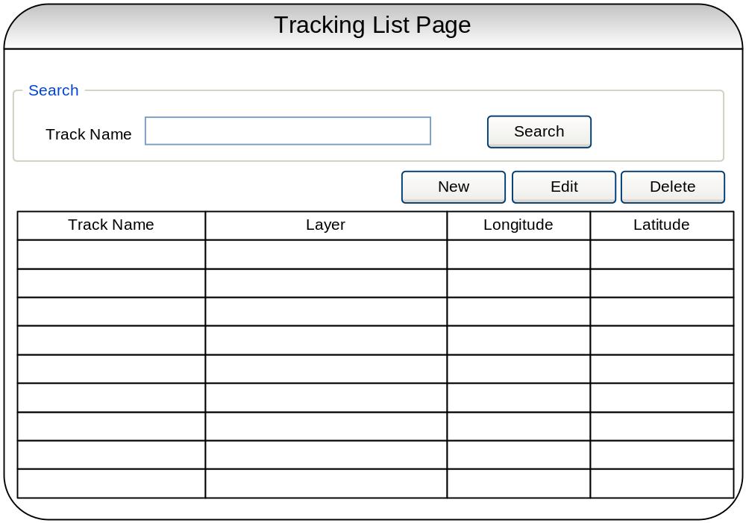

Name | Type | Description
Track Name | Textbox | To accept Track Name as search filter criteria.
Search | Button | Once the user clicks on Search button, it should populate group info into the grid base on the filter criteria.
Track Info Grid | Grid | Display list of track info.
New | Button | Once the user clicks on New button, it should open Manage Track screen to create new track.
Edit | Button | Once the user clicks on Edit button, it should open Manage Track screen to edit selected tracking client info in the grid.
Delete | Button | Once the user clicks on Delete button, it should ask for the confirmation and delete from the database once the user confirm for the deletion.

Manage Track

The Manage Track screen will appear when the user clicks on the New or the Edit button on the Track List screen. Track info should be populated on the form if user selects the Edit button on the Track List screen.
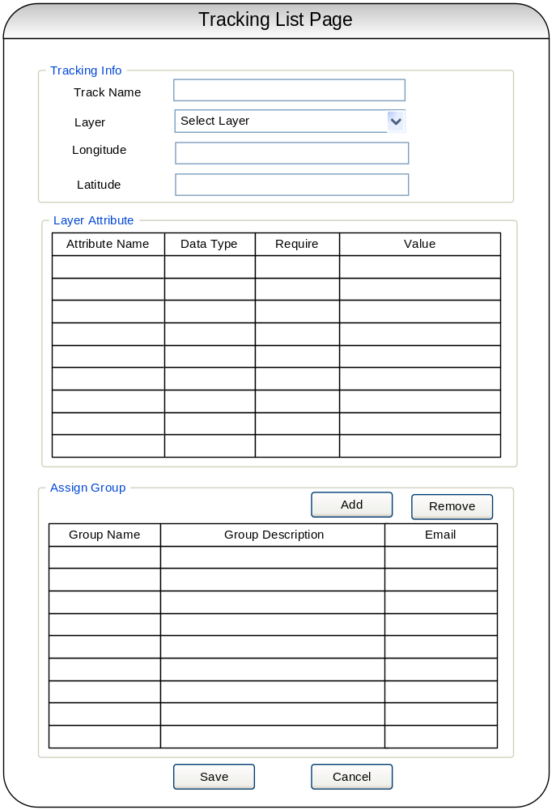

Name | Type | Description
Tracking Info | Group Box | For the grouping of the tracking info controls.
Track Name | Textbox | To accept the track name.
Description | Textbox | To accept the description of the track.
Layer | Dropdown List | To select a layer. Attribute Info Grid in the Layer Attribute section should be populated automatically once the user selects a layer from the drop down list.
Longitude | Textbox | To accept the longitude
Latitude | Textbox | To accept the latitude
Layer Attribute | Group Box | For the grouping of setting layer attribute to the track.
Attribute Info Grid | Grid | To set the value of the layer attributes. Value column in the grid should be editable.
Assign Group | Group Box | For the grouping of adding and removing group to the track.
Group Info Grid | Grid | Display list of groups that assign to the tracking client
Add | Button | Once the user clicks on this button, it should open up the Select Group(s) screen which enables the user to select the groups and add in the group list that belongs to the tracking.
Remove | Button | Once the user clicks on this button, selected group(s) will be deleted from the group list of the tracking client.
Save | Button | Once the user clicks on save button, it should perform require validation and save into the database. After saving into the database, it should go back to the Track List screen and tracking client info grid should be reflected with the changes.
Cancel | Button | Once the user clicks on Cancel button, it should show changes lost warning message and ask for the confirmation. Close the Manage Track screen and go back to Track List Screen if user confirms to cancel.

Select Group(s) Screen

The Select Member(s) screen will appear when the user clicks the Add button on the Manage Group screen.

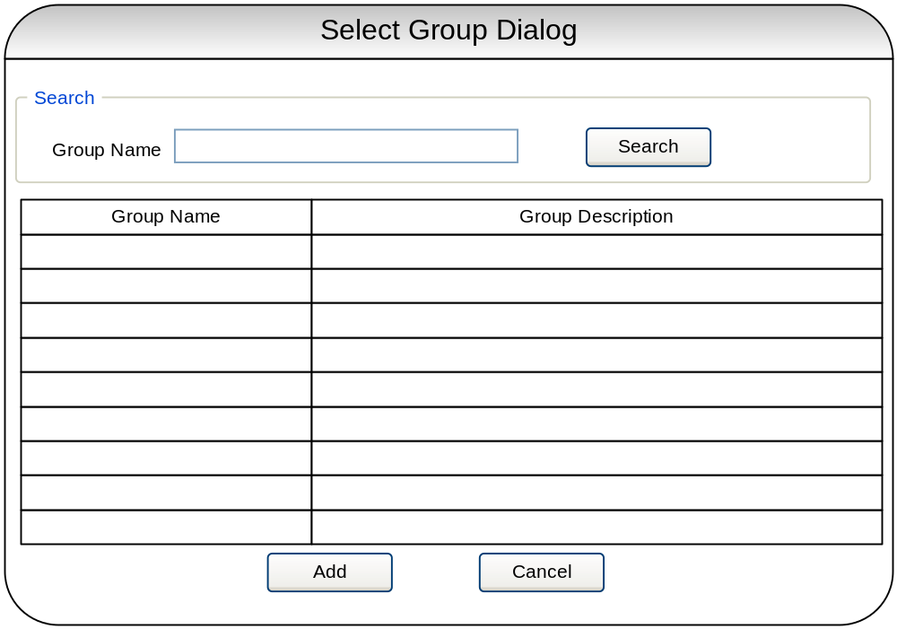

Name | Type | Description
Group Name | Textbox | To accept Group Name as search filter criteria.
Search | Button | Once the user clicks on Search button, it should populate user info into the grid base on the filter criteria.
Group Info Grid | Grid | Display list of group info.
Add | Button | Once the user clicks on Add button, it should return selected group(s) to the Manage Tracking Client screen and add to the group list.
Cancel | Button | Once the user clicks on Cancel button, it should close the dialog and go back to Manage Tracking Client screen.

Layer List Screen

The Layer List screen will appear when the user clicks on Manage Layer on the Admin Main Screen.

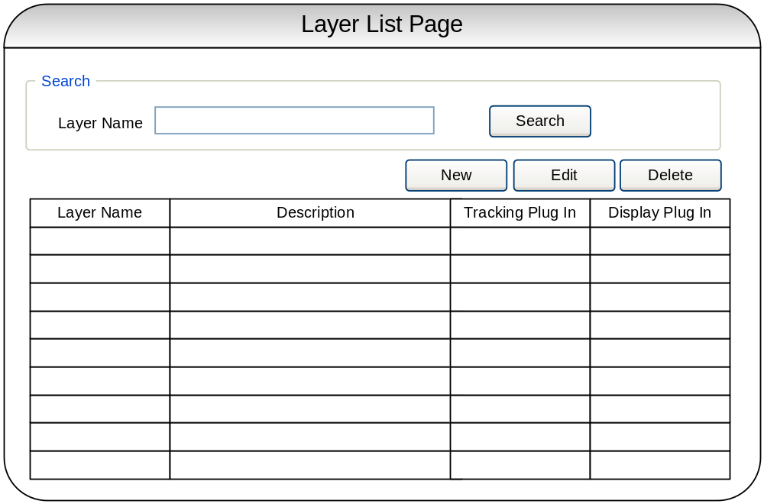

Name | Type | Description
Layer Name | Textbox | To accept Layer Name as search filter criteria.
Search | Button | Once the user clicks on Search button, it should populate group info into the grid base on the filter criteria.
Layer Info Grid | Grid | Display list of layer info.
New | Button | Once the user clicks on New button, it should open Manage layer screen to create new layer.
Edit | Button | Once the user clicks on Edit button, it should open Manage layer screen to edit selected layer info in the grid.
Delete | Button | Once the user clicks on Delete button, it should ask for the confirmation and delete from the database once the user confirm for the deletion.

Manage Layer Screen
The Manage Layer screen will appear when the user clicks on the New or the Edit button on the Layer List screen. The layer information will be populated in the form fields if user selects the Edit button on the Layer List screen.

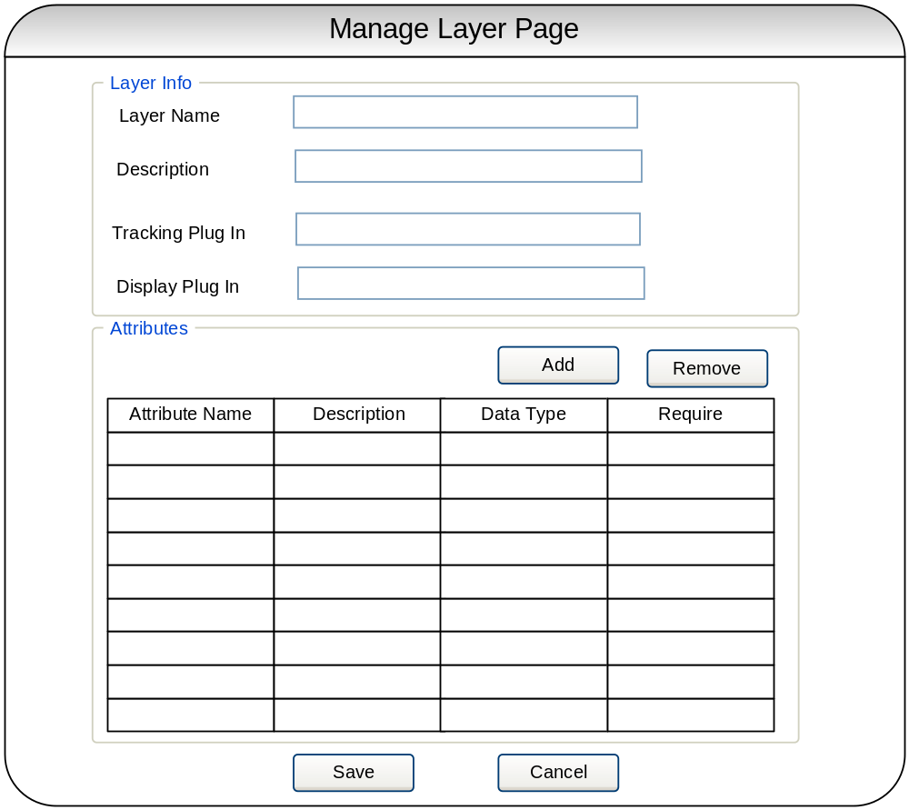

Name | Type | Description
Layer Info | Group Box | For the grouping of the layer info controls.
Layer Name | Textbox | To accept the layer name.
Description | Textbox | To accept the description of the layer.
Tracking Plug In | Textbox | To accept the name of the tracking plug in
Display Plug In | Textbox | To accept the name of the display plug in
Attributes | Group Box | For the grouping of adding and removing attribute to layer.
Attribute Info Grid | Grid | Display list of attribute that belong to the layer
Add | Button | Once the user clicks on this button, it should open up the Attribute screen which enables the user to key in attribute info and add in the attribute list.
Remove | Button | Once the user clicks on this button, selected attribute(s) will be deleted from the attribute list.
Save | Button | Once the user clicks on save button, it should perform require validation and save into the database. After saving into the database, it should go back to the Layer List screen and layer info grid should be reflected with the changes.
Cancel | Button | Once the user clicks on Cancel button, it should show changes lost warning message and ask for the confirmation. Close the Manage Layer screen and go back to Layer List Screen if user confirms to cancel.

Attribute Screen

The Attribute screen will appear when the user clicks on the Add button on the Manage Layer screen.

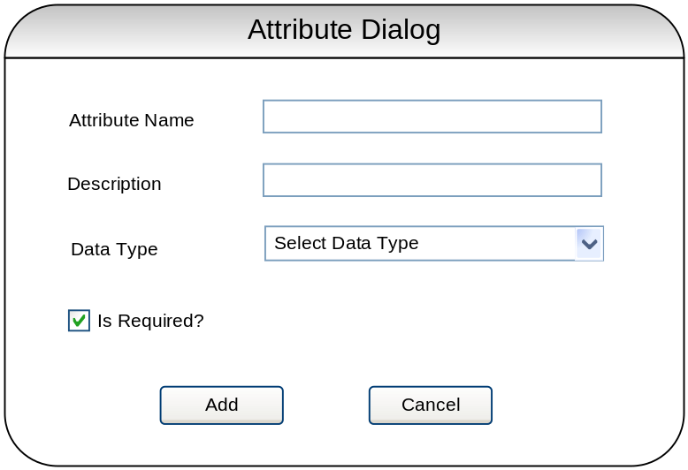

Name | Type | Description
Attribute Name | Textbox | To accept the name of the attribute.
Attribute Description | Textbox | To accept the description of the attribute.
Data Type | Dropdown List | To accept the data type of the attribute. (Only four types are allow: Boolean, string, numeric, and date time)
Is Required? | Checkbox | To identify the attribute is a mandatory.
Add | Button | Once the user clicks on Add button, it should return the attribute info to the Manage Layer screen and add to the group list.
Cancel | Button | Once the user clicks on Cancel button, it should close the dialog and go back to Manage Layer screen.

